**Beaker Communication Diagrams**

**And Class Diagram II**

Jay Patel

Christian Klein

Joseph Thill

Derek Yu

Zifeng Jiang

**Use Case 1 - New Previous Cell**

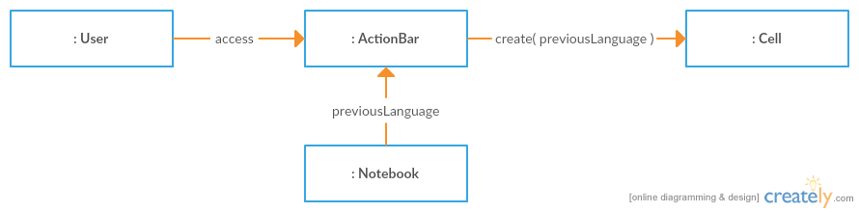

**Use Case 2 - Create New Empty Workbook**

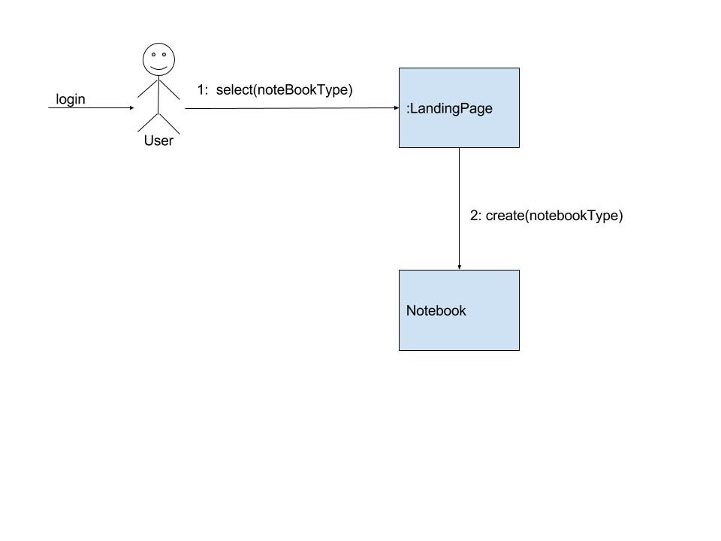

**Use Case 3 - Report Bug**

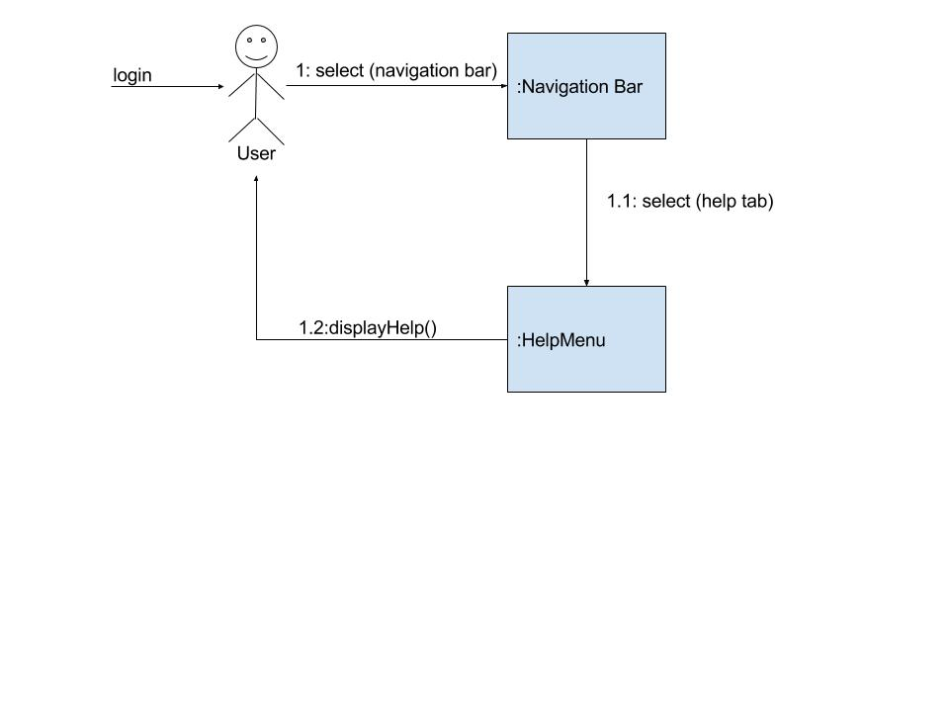

**Use Case 4 - Switch to Advanced View**

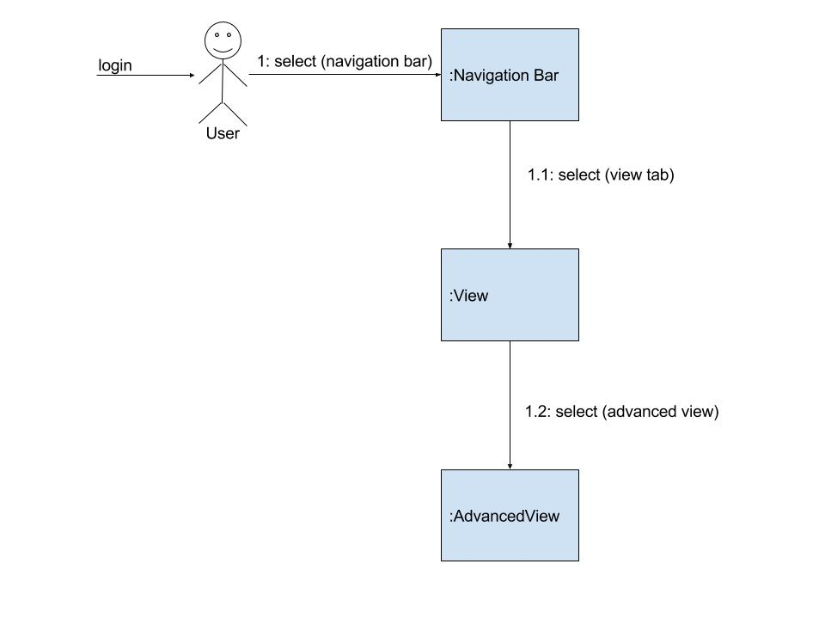

**Use Case 5 - New Cell**

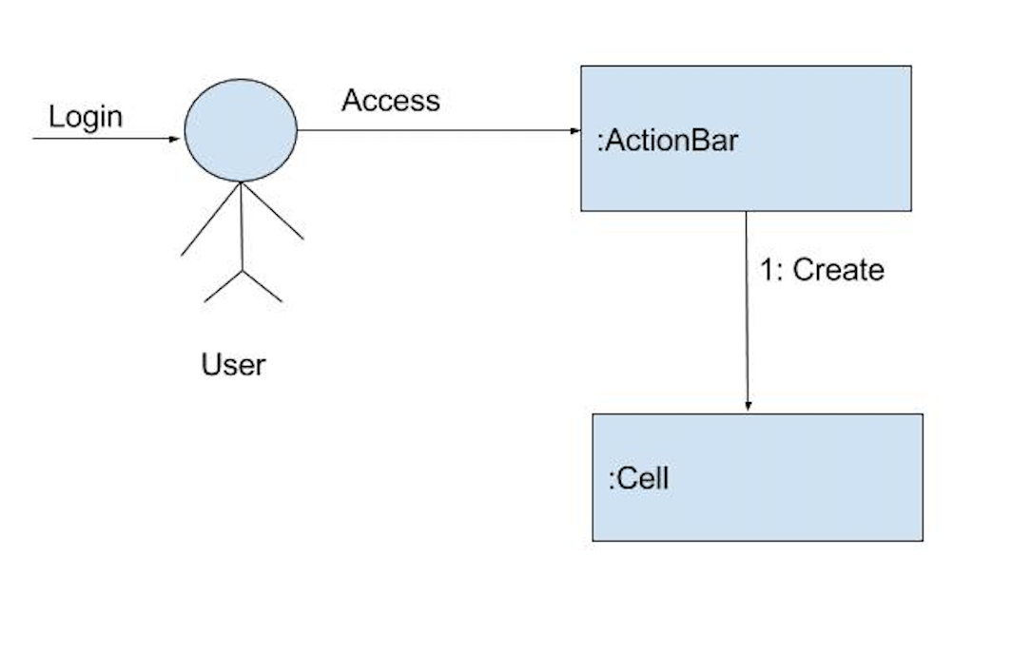

**Use Case 6 - New Textbox**

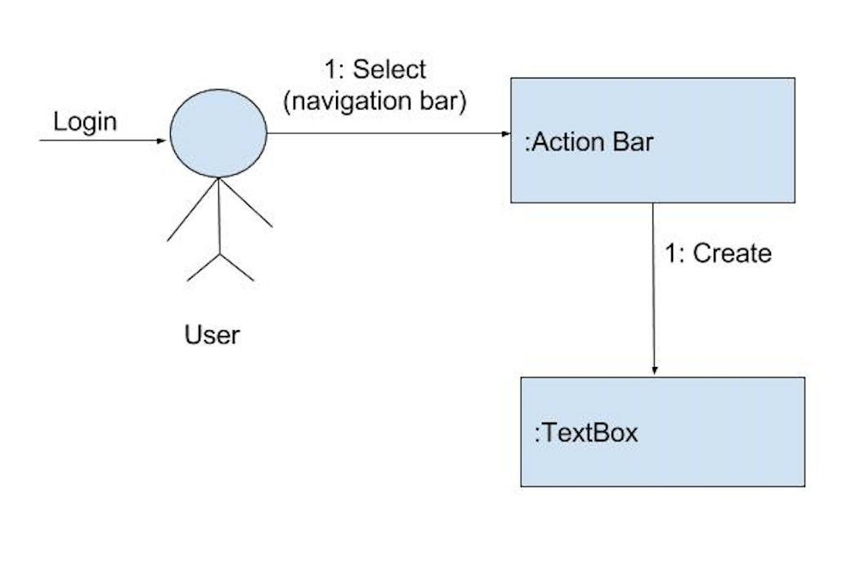

**Use Case 7 - Run Cell**

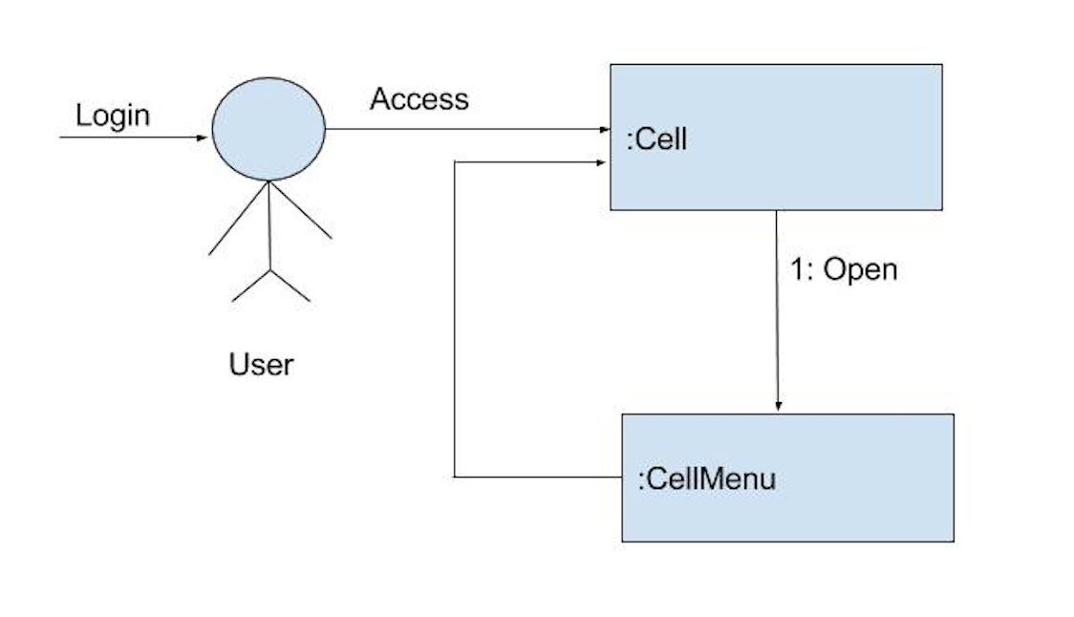

**Use Case 8 - Open Javascript Tutorial**

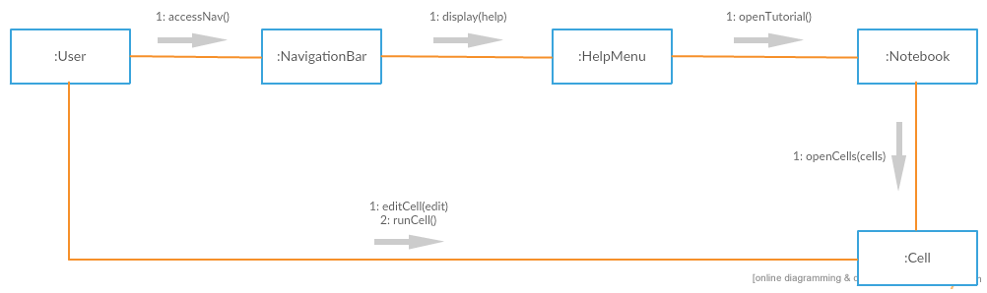

**Use Case 9 - Upload File**

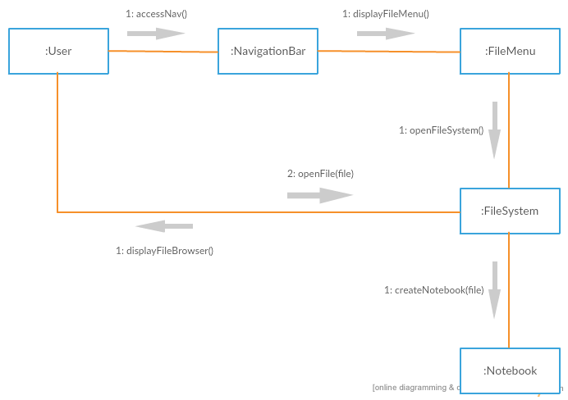

**Use Case 10 - Publish**

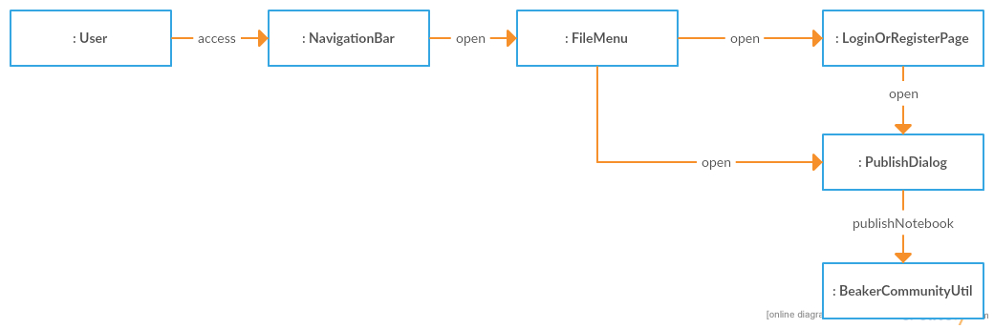

**Use Case 11 - Delete Cell**

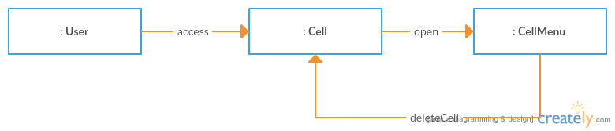

**Use Case 12 - Save Notebook**

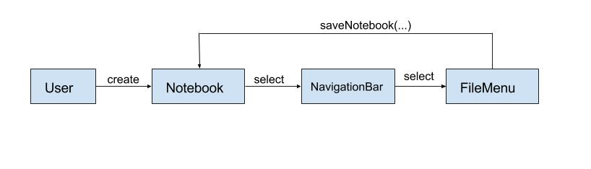

**Use Case 13 - Create Sections**

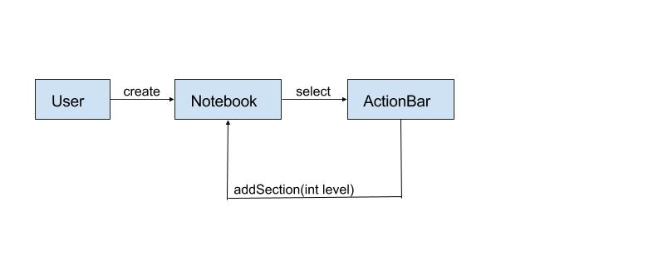

**Use Case 14 - Run All Cells**

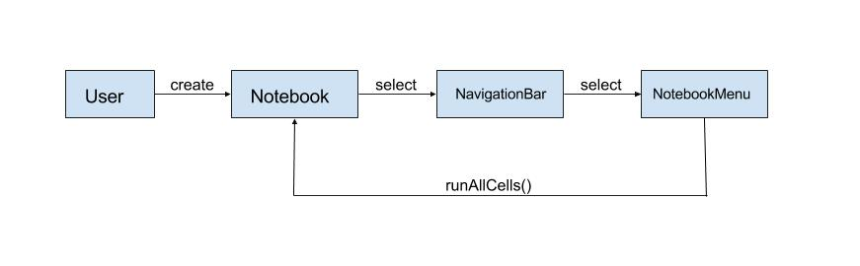

**CRC Cards**

**Class:** User

**Responsibility:** Represents the user; contains user’s credentials and Notebook(s) created

**Collaborators:** LandingPage, Notebook

**Class:** Cell

**Responsibility:** Contains program language and performs actions upon itself

**Collaborators:** Notebook

**Class:** LandingPage

**Responsibility:** Initial page user sees; creates Notebooks

**Collaborators:** User, Notebook

**Class:** PublishDialog

**Responsibility:** Prompts the user for publishing info and publishes the Notebook

**Collaborators:** FileMenu

**Class:** NavigationBar

**Responsibility:** Bar atop the Notebook for Notebook-wide operations

**Collaborators:** Notebook, FileMenu, ViewMenu, NotebookMenu, HelpMenu

**Class:** Notebook

**Responsibility:** Helps the user to write/edit the code, and do other operations

**Collaborators:** Section, TextBox, ActionBar, Cell

**Class:** Section

**Responsibility:** Allows the user to make a tree-like structure

**Collaborators:** Notebook

**Class:** TextBox

**Responsibility:** Allows the user to type literal strings

**Collaborators:** Notebook

**Class:** FileMenu

**Responsibility:** Collects operations for user to edit the notebook

**Collaborators:** NavigationBar, PublishDialog

**Class:** ViewMenu

**Responsibility:** Collects operations for user to change the interface

**Collaborators:** NavigationBar

**Class:** ActionBar

**Responsibility:** Helps user to insert different elements into the notebook

**Collaborators:** Notebook

**Class:** HelpMenu

**Responsibility:** Allows user to run a tutorial notebook or report a bug or feature to developers

**Collaborators:** GitUtility

**Class:** NotebookMenu

**Responsibility:** Runs all notebook cells and other functionality related to the current notebook

**Collaborators:** Notebook, NavigationBar

**Class Diagram**

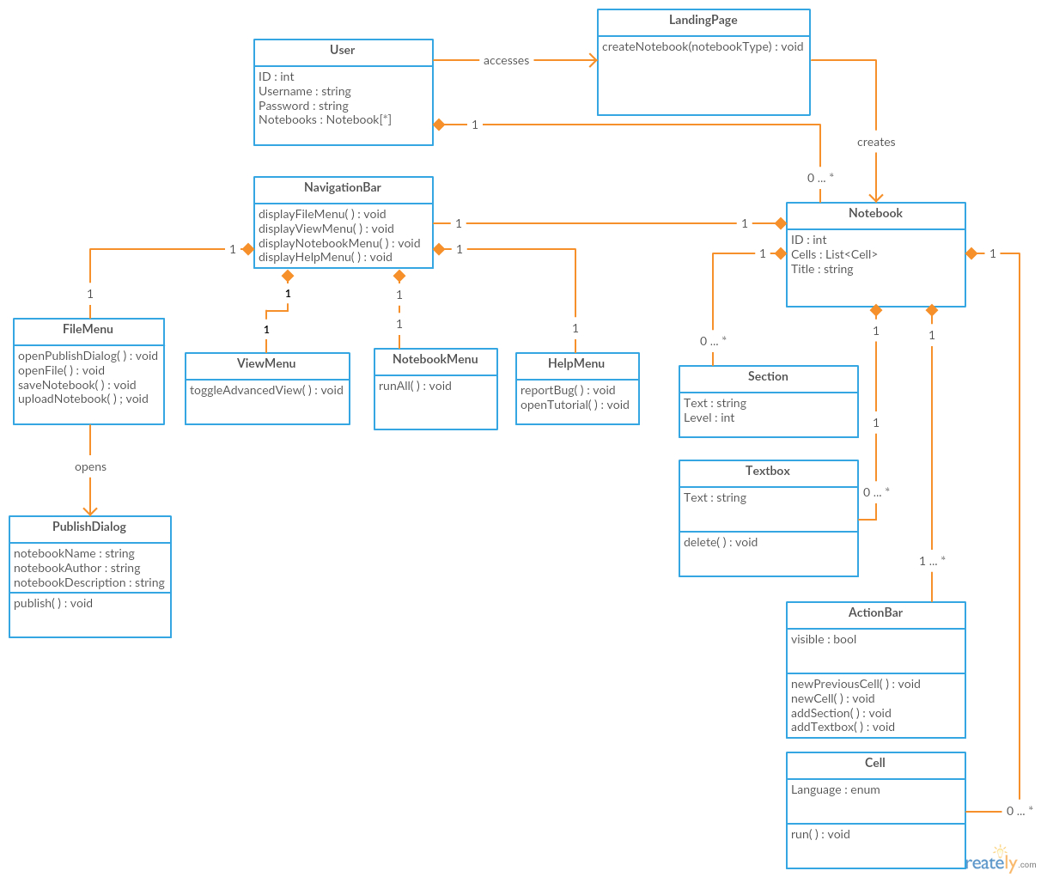

**Com S 362 — Object-Oriented Analysis and Design**

**Certification of Individual Contribution and Understanding Form**

Project Name: Communication and Class Diagrams Team Facilitator: Jay Patel

Homework Set: Studio #7 Date: 10-15-2016

Directions: Enter each team member’s name, and a “work rating” (1 - 5 with 5 as high and 1 as low score) that corresponds to the relative share of work done by the team member. Comments to explain work ratings other than 3 must also be provided. The total of the ratings must add up to 3 times the number of team members. Each team member must sign at the end of the form showing your agreement to your team member’s contribution.

*The work rating will have a direct and significant effect on each student’s project and ultimately course grade. In fairness to all students, each team member must give this rating their attention.*

Also, each team member should individually rate the percentage that they understand of the solution. (This does not affect the grade, but is used as a means of communication.)

|  |  |  |  |
| --- | --- | --- | --- |
| Printed team member’s name | Work  Rating  (1 - 5) | Comments/Explanations | Understanding  Self Rating  (0 to 100%) |
| Christian Klein | 3 |  | 90% |
| Derek Yu | 3 |  | 90% |
| Jay Patel | 3 |  | 90% |
| Joe Thill | 3 |  | 90% |
| Zifeng Jiang | 3 |  | 90% |
| Total: | 15 |  | |

Note that you must make Total = 3 * (Number of team members)

|  |
| --- |
| I agree to the above ratings and understand our team’s solution. |
| Christian Klein |
| Derek Yu |
| Jay Patel |
| Joe Thill |
| Zifeng Jiang |